Mid Ulster Volunteer Centre

APPLICATION FORM
Please complete this form legibly and in black ink and return it on or before the closing date specified in the advertisement. Late applications will not be considered. ONLY INFORMATION PROVIDED ON THIS APPLICATION FORM WILL BE CONSIDERED BY THE PANEL AT THE SHORTLISTING STAGE. Curriculum vitae will not be accepted. Candidates must outline clearly how their qualifications and experience meet both the essential and desirable requirements. All information given will be treated with the strictest confidence. Continuation sheets may be added if necessary.

1. POSITION APPLIED FOR: Project Assistant & Support Worker

2. PERSONAL DETAILS
Title: | Address:
Surname:
Forenames:
Telephone number (Home): | Postcode:
Telephone number (Mobile): | Email:

Do you have the right to work in the UK?  Note: the company will require proof of this right before an offer of employment can be confirmed – e.g. Birth certificate and/or any other appropriate document required to confirm your right to work in the UK as required by the Asylum and Immigration Act 1996 | Yes | No

The requirements of the post involve travelling to other venues over Northern Ireland  Do you have the ability to travel to various locations as and when required?  (Possession of a full driving licence and access to a car for business or have a means to fulfil the travel requirements of the post) | Yes | No

3. EDUCATION
From | To | Examination Taken | Subject | Grades

4. FURTHER/ HIGHER EDUCATION
From | To | Name of Institution  (state if Full or Part Time) | Subjects Taken and Qualifications Gained (Specify Grades or Degree Class Obtained)

6. EMPLOYMENT RECORD (Please list chronologically, starting with current or last employer)
Name and Address of Employer and Nature of Business: | From:  To: | Job Title:  Job Function/ Responsibilities: | Final Salary and Reason for Leaving

7. TRAINING
Details of training courses attended and awards achieved, including dates, if appropriate:

8. VOLUNTEERING

Please give details of any volunteering experience listing in chronical order:
Date |  | Name and Address of Organisation | Brief description of role
To | From

9. SUPPORTING STATEMENT

Demonstrate your experience, skills, knowledge and achievements against the criteria listed in the Person Specification. Address each point separately, in numerical order, giving examples and evidence where possible to support your application. You can attach extra A4 sheets as a word document with a minimum font size 12.

10. DISABILITY DISCRIMINATION ACT 1995
If you require any special arrangements to be made to assist you if called for interview, please let us know in advance of the interview.

11. REFEREES
Please give the details of two work related referees, including your current or most recent post. Referees will not be contacted without your prior approval.
Name: | Name:
Position: | Position:
Company: | Company:
Address: | Address:
Contact Number: | Contact Number:
Email Address: | Email Address:
Nature of Relationship: | Nature of Relationship:

12. VERIFICATION OF INFORMATION
I certify that all information which I have provided is correct. I understand that any false information given may result in a job offer being withdrawn.

Signature: Date:

Please complete the separate monitoring form enclosed.

The successful applicant will be required to complete an AccessNI disclosure. A criminal record will not necessarily be a bar to obtaining a position. A copy of our policy on the Recruitment of ex-offenders is available upon request.

The Volunteer Centre complies with AccessNI’s Code of Practice, which can be viewed online via our website or available upon request.

Please return your application to:  Mid Ulster Volunteer Centre  20 Queen Street  Magherafelt  BT45 6AB  Or by email to:  mairead@midulstervolunteercentre.org | Closing Date:  4pm – Friday 29 October 2021  (Interviews will be held on  Thursday 4 November 2021)

Declaration of Criminal Convictions, Cautions and Bind-Over Orders

In Confidence –

Do you have any prosecutions pending? YES No

If yes, please give details

Declaration of Abuse Investigation(s)

Is there any reason you cannot work in regulated activity? YES NO
Regulated activity is something that a person working in Northern Ireland must not do if the Disclosure and Barring Service (DBS) has “barred” them from working with children and adults. It is an offence for a barred person to do such work or to apply to do such work.
Where an individual is working in regulated activity with children or adults, they are entitled to apply for an AccessNI enhanced check, together with a check of the “barred” lists held by the Disclosure and Barring Service and the Scottish government.
If yes, please list full details below including the name of police unit or HSC Trust involved in the investigation. If possible please provide the approximate date/s.

Declaration and Consent

I declare that the information I have given is complete and accurate. I understand that I will be asked to complete an AccessNI Disclosure Certificate Application Form if I am considered to be the preferred candidate and I consent to the Disclosure Check being made, and I agree to inquiries relevant to this declaration.
Signed: Date:
Print Name:
Any surname previously known by:
Position applied for:

This self-declaration form must be returned in separate envelopes

Data Protection Act 1998

As part of the recruitment procedure we may collect and store sensitive personal data about you. We are required by law to obtain your consent to such data being recorded. It is our policy to store data relating to recruitment procedures for up to a year after the date on which it is submitted. Any information of this nature will be treated confidentially. Sensitive personal data is defined as information relating to any of the following: racial or ethnic origin, political opinions, religious beliefs, trade union membership, health, sexuality or sex life, offences and/or convictions.

For the purposes of the Act the Data Controller is Mid Ulster Volunteer Centre.

I give my consent to sensitive personal information being recorded and stored.

Signed ………………………………………..

Date: ………………………………………..

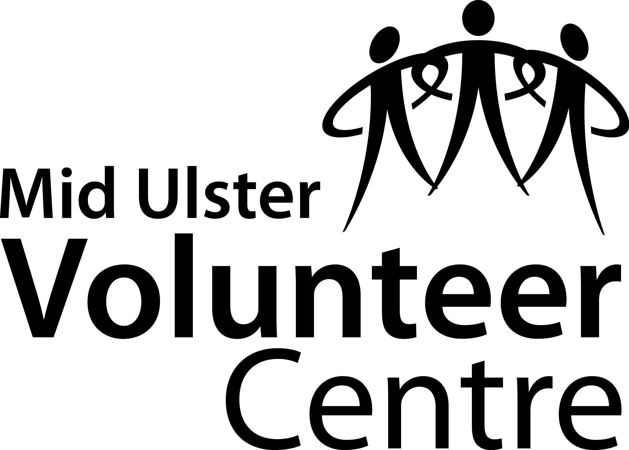

Monitoring information

Mid Ulster Volunteer Centre aims to provide equal opportunities and fair treatment for all people applying for this post regardless of race, sex, disability, sexual identity, age or marital status.

In order to achieve these aims we have a policy of monitoring the recruitment and composition of the organisations staff and volunteers. All information will be treated confidentially. This information will not affect your application.

Age <25 25-34 35-44 45-54 55-64 65+

Gender Female Male

Do you consider yourself to have a disability? Yes No

Ethnic Origin

White
British Irish Other White

Mixed
White and Black Caribbean White and Black African White and Asian
Mixed British Other Mixed

Asian or Asian British
Indian Pakistani Bangladeshi Other Asian

Black or Black British
Black Caribbean Black African Other Black

Gypsy / traveller
Gypsy / traveller

Chinese or Other Ethnic Group
Chinese Other Ethnic Group

