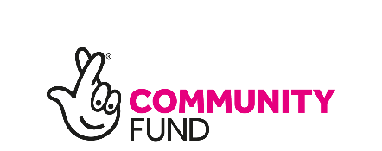
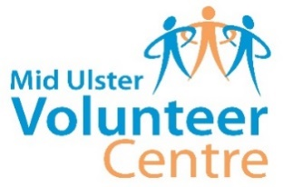
Carefully Yours Project
Registration Form 2020/21

Personal Details
Title: |  | Mr / Mrs / Ms / Miss / Other:
Name:
Address: |  |  | Postcode:  DOB:
Phone: |  |  | Mobile:
GP Name
& Address

Medical Information & Emergency Contact Details
Medical Details: (Conditions, Disabilities, Allergies, etc) Please include as much information as possible.

Emergency Contact:

Phone: |  |  | Relationship  to you:
Activities/Interests:. This will help us to provide a programme of activities that users want.

Do you live alone? Yes / No
How did you first hear about/get involved with the project?
- Family  - Friend  - Bulletin/Newsletter  - Other Organisation e.g Local Council, Charity, Group: _________________ | - GP  - Social Worker/Support Worker  - Other Health Professional e.g. Physio  If above, please give details: _________  _________________________________

